Project Design Phase
Solution Architecture

Date | 30 September 2026
Team ID | SWTID-2026-7062
Project Name | AL BLOG NEST
Maximum Marks | 4 Marks

Solution Architecture:
Solution architecture is a complex process – with many sub-processes – that bridges the gap between business problems and technology solutions. Its goals are to:
- Find the best tech solution to solve existing business problems.
- Describe the structure, characteristics, behavior, and other aspects of the software to project stakeholders.
- Define features, development phases, and solution requirements.
- Provide specifications according to which the solution is defined, managed, and delivered.

Example - Solution Architecture Diagram:


Figure 1: Architecture and data flow of the voice patient diary sample application
Reference: https://aws.amazon.com/blogs/industries/voice-applications-in-clinical-research-powered-by-ai-on-aws-part-1-architecture-and-design-considerations/

Solution Architecture Diagram – AL BLOG NEST:
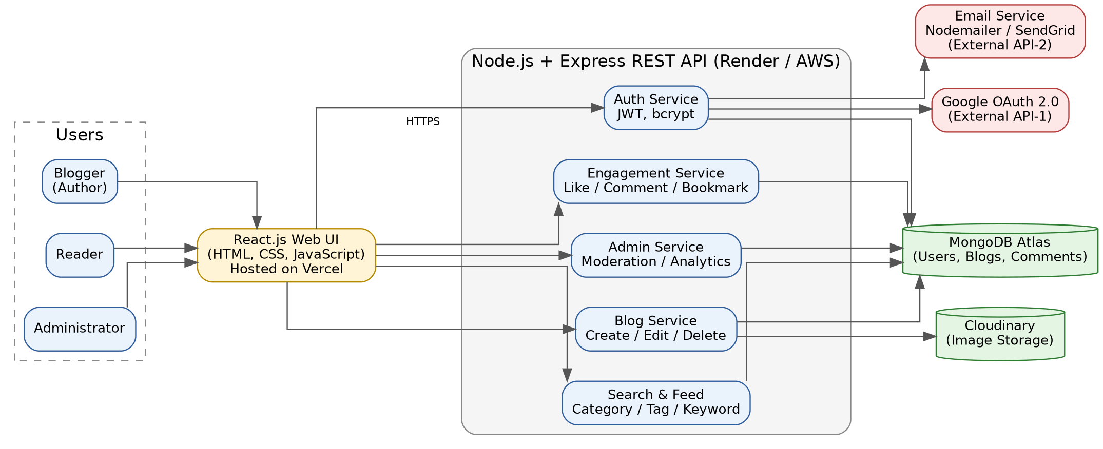
Figure 2: Architecture and data flow of AL BLOG NEST
Layer | Description
Users | Blogger (author), Reader and Administrator access the platform through a web browser on desktop or mobile.
Presentation layer | React.js single-page application (HTML, CSS, JavaScript) hosted on Vercel; communicates with the backend using secure REST calls over HTTPS.
Application layer | Node.js + Express REST API with separate modules: Auth Service (JWT, bcrypt), Blog Service (create / edit / delete / publish), Search & Feed Service, Engagement Service (like, comment, bookmark) and Admin Service (moderation, analytics).
Data layer | MongoDB Atlas stores users, blog posts, comments, likes and bookmarks. Cloudinary stores and delivers blog cover images and profile pictures.
External services | Google OAuth 2.0 for Gmail sign-in and an email service (Nodemailer / SendGrid) for verification and password-reset mails.
Security & deployment | Passwords hashed with bcrypt, token-based access with role checks (user / admin), input validation and HTTPS. Frontend on Vercel, backend on Render / AWS, database on MongoDB Atlas.

